# Algorithm for file updates in Python

## Project description

At my organization, access to restricted content is controlled with an allow-list of IP addresses.

The "allow_list.txt" file identifies such IP addresses. A separate remove list identifies IP

addresses that should no longer have access to the content. I created an algorithm to

automate updating the "allow_list.txt" file and remove these IP addresses that should

no longer have access.

## Open the file that contains the allow-list

## For the first part of the algorithm, I opened the "allow_list.txt" file. Firstly, I assigned this file name as a string to the import_file variable:



Then, I used a with statement to open the file:



In my algorithm, the with statement is used with the open() function in read mode to open the allow-list file for the purpose of reading it. The purpose of opening the file is to allow me to access the IP addresses stored in the allow-list file. The with keyword will help manage the resources by closing the file after exiting the with statement. In the code with open(import_file, "r") as file:, the open() function has two parameters. The first identifies the file to import, and then the second indicates what I want to do with the file. In this case, "r" indicates that I want to read it. The code also uses the as keyword to assign a variable named file; file stores the output of the .open() function while I work within the with statement.

## Read the file contents

In order to read the file contents, I used the .read() method to convert it into the string.

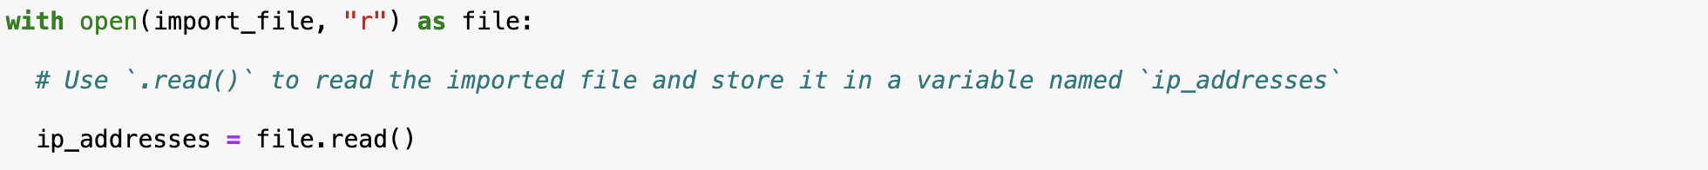

When using an open() function that includes the argument "r" for “read,” I can call the .read() function in the body of the with statement. The .read() method converts the file into a string and allows me to read it. I applied the .read() method to the file variable identified in the with statement. Then, I assigned the string output of this method to the variable ip_addresses.

To summarize, this code reads the contents of the "allow_list.txt" file into a string format that allows me to later use the string to organize and extract data in my Python program.

## Convert the string into a list

In order to remove individual IP addresses from the allow-list, I needed it to be in list format. Thus, I next used the .split() method to convert the ip_addresses string into a list:



The .split() function is called by appending it to a string variable. It works by converting the contents of a string to a list. The purpose of splitting ip_addresses into a list is to make it easier to remove IP addresses from the allow-list. By default, the .split() function splits the text by whitespace into list elements. In this algorithm, the .split() function takes the data stored in the variable ip_addresses, which is a string of IP addresses that are each separated by a whitespace, and it converts this string into a list of IP addresses. To store this list, I reassigned it back to the variable ip_addresses.

## Iterate through the remove list

A key part of my algorithm involves iterating through ip_addresses. To do this, I incorporated a for loop:



The for loop in Python repeats code for a specified sequence. The overall purpose of the for loop in a Python algorithm like this is to apply specific code statements to all elements in a sequence. The for keyword starts the for loop. It is followed by the loop variable element and the keyword in. The keyword in indicates to iterate through the sequence ip_addresses and assign each value to the loop variable element.

## Remove IP addresses that are on the remove list

My algorithm requires removing any IP address from the allow-list, ip_addresses, that is also contained in remove_list. Because there were not any duplicates in ip_addresses, I was able to use the following code to do this:

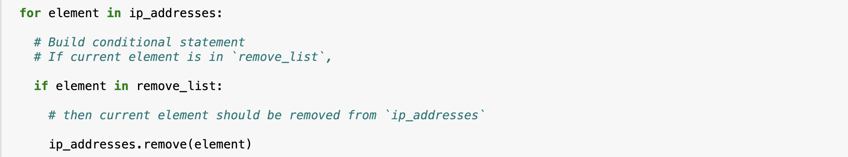

First, within my for loop, I created a conditional that evaluated whether or not the loop variable element was found in the ip_addresses list. I did this because applying .remove() to elements that were not found in ip_addresses would result in an error.

Then, within that conditional, I applied .remove() to ip_addresses. I passed in the loop variable element as the argument so that each IP address that was in the remove_list would be removed from ip_addresses.

## Update the file with the revised list of IP addresses

As a final step in my algorithm, I needed to update the allow-list file with the revised list of IP addresses. To do so, I first needed to convert the list back into a string. I used the .join() method for this:



The .join() method combines all items in an iterable into a string. The .join() method is applied to a string containing characters that will separate the elements in the iterable once joined into a string. In this algorithm, I used the .join() method to create a string from the list ip_addresses so that I could pass it in as an argument to the .write() method when writing to the file "allow_list.txt". I used the string ("\n") as the separator to instruct Python to place each element on a new line.

Then, I used another with statement and the .write() method to update the file:

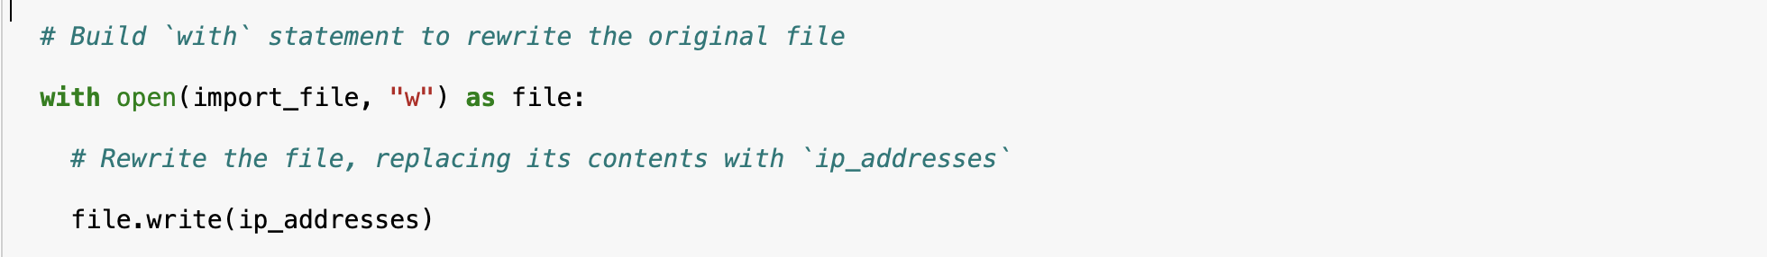

This time, I used a second argument of "w" with the open() function in my with statement. This argument indicates that I want to open a file to write over its contents. When using this argument "w", I can call the .write() function in the body of the with statement. The .write() function writes string data to a specified file and replaces any existing file content.

In this case I wanted to write the updated allow-list as a string to the file "allow_list.txt". This way, the restricted content will no longer be accessible to any IP addresses that were removed from the allow-list. To rewrite the file, I appended the .write() function to the file object file that I identified in the with statement. I passed in the ip_addresses variable as the argument to specify that the contents of the file specified in the with statement should be replaced with the data in this variable.

## Summary

I created an algorithm that removes IP addresses identified in a remove_list variable from the "allow_list.txt" file of approved IP addresses. This algorithm involved opening the file, converting it to a string to be read, and then converting this string to a list stored in the variable ip_addresses. I then iterated through the IP addresses in remove_list. With each iteration, I evaluated if the element was part of the ip_addresses list. If it was, I applied the .remove() method to it to remove the element from ip_addresses.. After this, I used the .join() method to convert the ip_addresses back into a string so that I could write over the contents of the "allow_list.txt" file with the revised list of IP addresses.